SIMULATION/VERIFICATION

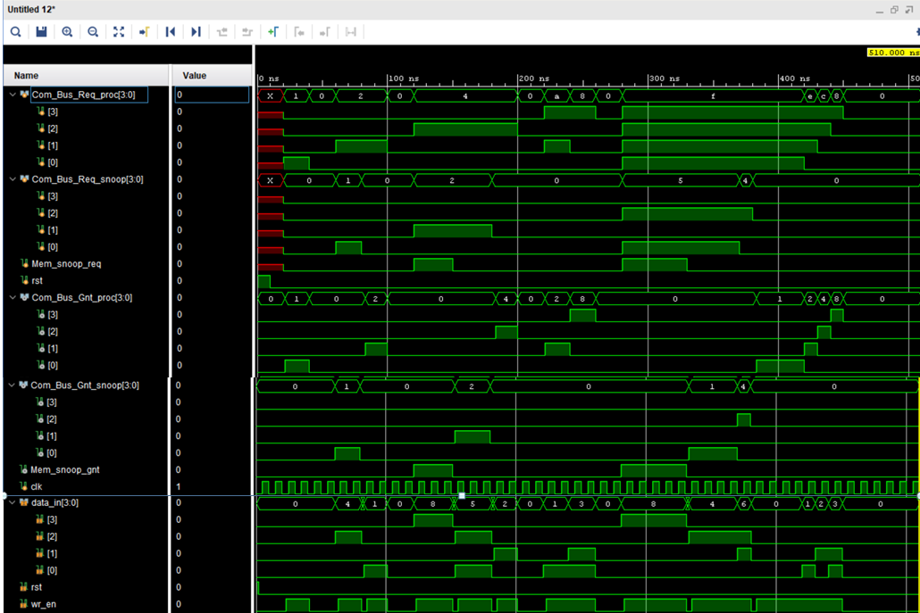

All tests passed!

